Kingdom of Saudi Arabia  Ministry of Education  Hafr Al Baten Educational Directorate for boys  Al –Ajial International Schools |  |  |  |      |  |  | Subject: Computer  Class.: Grade 6  Time:……….
……………… |  | Seat Number |  | ………………………………………… |  |  |  | Student’s Name
MID-SEMESTER EXAM
FIRST SEMESTER 2024/2025 SESSION
Sign. | Consultative Name |  | Sign. |  | Corrector’s Name | Marks in letters |  |  | Marks  in numbers
 |  |  |  |  |  |  |  |  | 20
INSTRUCTION: ANSWER ALL QUESTIONS

Question A: State whether the statements are True/False.
- The unite tool removes the overlaying shape from the parent shape.
_____________
- The toolbar consists of tools that are used to create an artwork.
______________
- We hold the shift key to select multiple shapes.
______________
- The page panel does not display pages available in the document and allows us to set page properties.
______________
- The shadow property casts a shadow of the object or shape.
_______________

Question B: Identify the meaning of the following signs

- 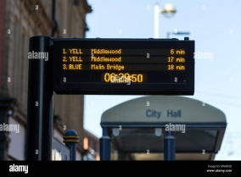 2. 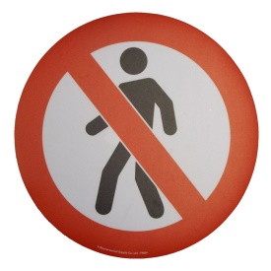

_____________________________ _____________________

4.  3. 
________________________ ______________________

5. 
______________________

GOOD LUCK

